Worksheet 6 Limits of computation

Task 1
1. (a) Complete the table below for different values of n.
n | 8 | 16 | 128
log₂n | 3 | 4 | 7
n log₂n | 24 | 64 | 896
n² | 64 | 256 | 163840
n³ | 512 | 4096 | 2097152
2^{n} | 256 | 65536 | 340,282,366,920,938,463,463,374,607,431,768,211,456 (a 39-digit number)
n! | 40320 | 20,922,789,888,000 | A very large number!

(b) Algorithms for problems A, B and C have time complexities O(n log₂n), O(n!) and O(n⁴).
Which of these problems are tractable, and which are intractable?
B is intractable, the rest aren’t

2. Choose a password of 8 lowercase alphabetic characters. Write the password below:

What is the big-O notation for a brute force algorithm to crack this password?

Log on to a site to test the strength of the password. You could try
https://howsecureismypassword.net/ or type into Google “How secure is my password” to find a different site. Assuming that the algorithm knows that the password is all lowercase:
How long will it take an average PC to crack the password?
How long would it take to crack a password with 16 lowercase letters?

If you use a mixture of eight uppercase and lowercase letters, digits and 28 other symbols, what is the big-O notation for the time complexity of the brute force algorithm?

How long will it take an average PC to crack it?

Is cracking a password an intractable problem?

Is cracking a password an insoluble problem?

Task 2

3. Complete the missing parts in the following paragraph about the Halting problem.:

It is __________________________________________ to devise a program H which can show that, given any program and its inputs, _____________________ ___________________________________________________________________
It is, however, often possible to show that given ______________________________, it will halt for any input.

4. What is the significance of the Halting problem?

5. Which of the following statements are true about the Travelling Salesman problem?
(a) The TSP is a non-computable problem
(b) The TSP can sometimes be solved using a brute-force algorithm
(c) Assuming a specific start city, the number of possible routes for 8 cities is double the number of routes for 4 cities
(d) Assuming a specific start city, there are fewer than 700 possible routes for 7 cities.
6. What is a tractable problem? Include in your answer the time complexities of tractable and intractable problems, using Big-O notation.

7. Go to http://www.hbmeyer.de/backtrack/backtren.htm , which models the performance of a backtracking algorithm. The aim of the algorithm is to find an arrangement of the 16 cards such that each side touches a “matching” card. There is no quick and efficient algorithm to solve this problem.

The jewels of Heuro

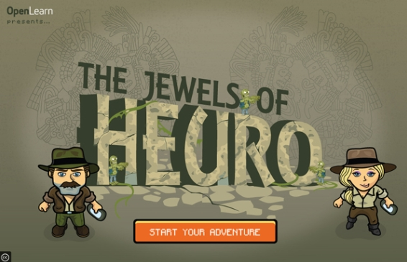

This game was written by Dr Michel Wermelinger (Faculty of Mathematics, Computing and Technology) at the Open University.

Try the game by following the link
http://www.open.edu/openlearn/science-maths-technology/computing-and-ict/computing/the-jewels-heuro

Write down the best route you found in your attempt to find the shortest tour at the end of the game, and the length of the tour.

